**Bank_Personal_Loan_Modelling**

**Code**

**# Importing all required files**

import pandas as pd

import numpy as np

from sklearn import tree

from sklearn import preprocessing

dataset=pd.read_csv("Bank_Personal_Loan_Modelling_1.csv")

dataset2=dataset.dropna() # this just to check null values are present or not thr is not difference in the number of rows

**# Creating model**

tree_model=tree.DecisionTreeClassifier()

**# Adding all columns for predictions**

predictor=pd.DataFrame([ dataset2['Age'], dataset2['Experience'], dataset2['Income'], dataset2['Family'],dataset2['CCAvg'],dataset2['Education'], dataset2['Mortgage'], dataset2['Securities Account'],dataset2['CD Account'], dataset2['Online'], dataset2['CreditCard']]).T

tree_model.fit(X=predictor,y=dataset2["Personal Loan"])

**# calculate Score**

score1_value=tree_model.score(X=predictor,y=dataset2["Personal Loan"])

print(" Score value ",score1_value)

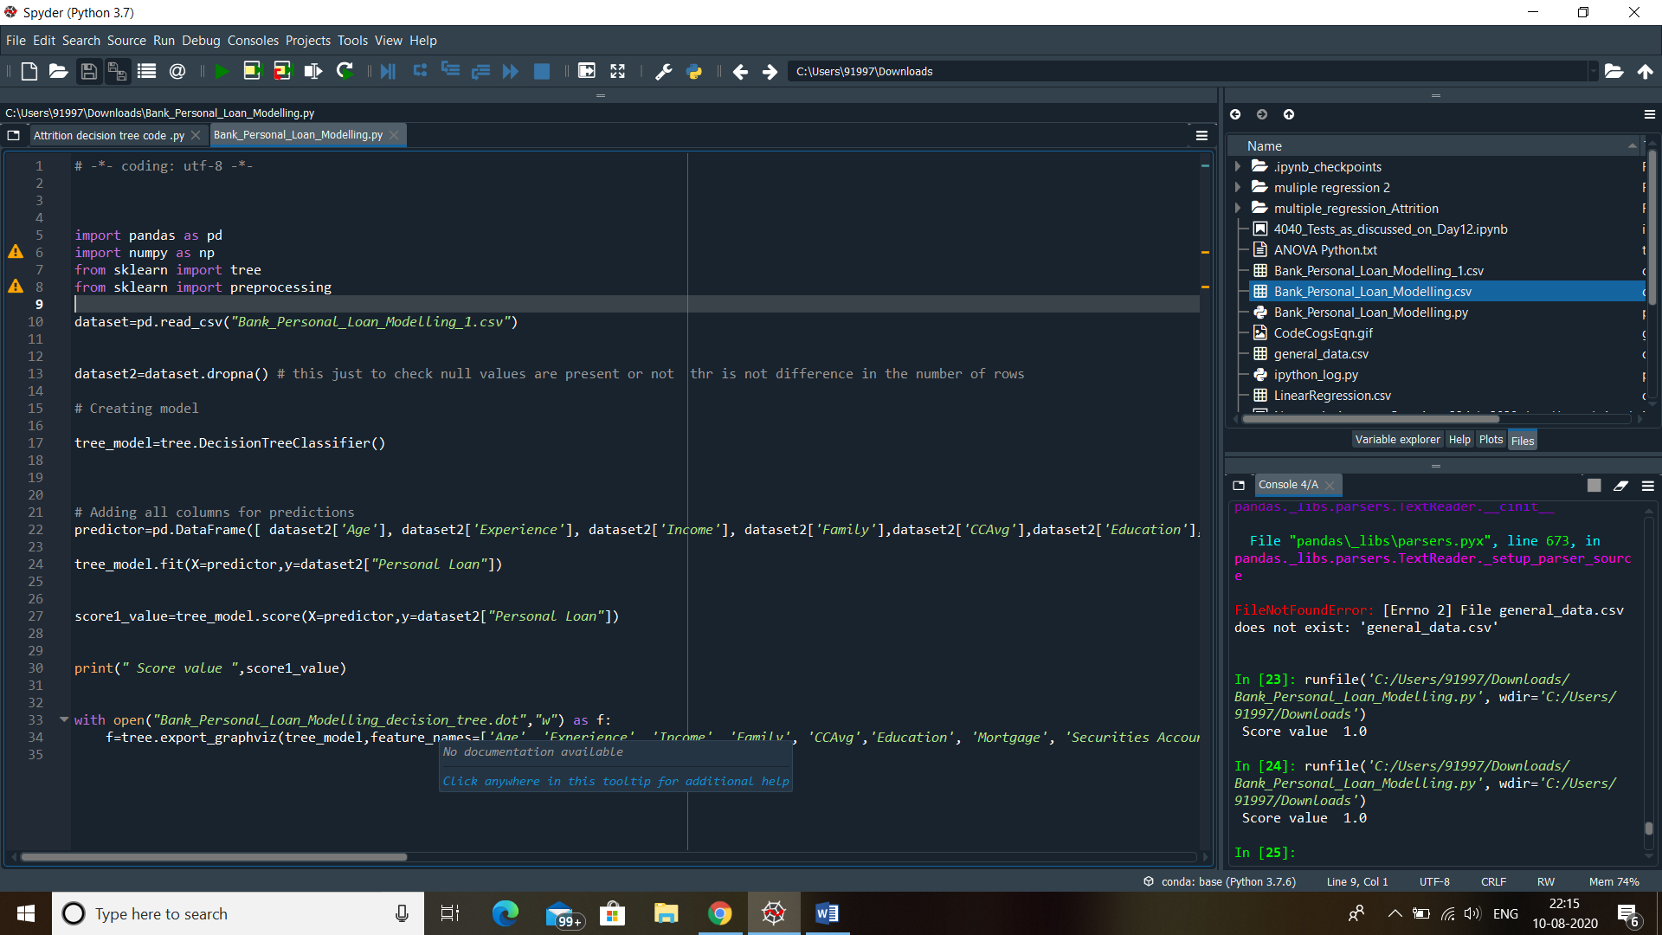

**# Exporting decision tree**

with open("Bank_Personal_Loan_Modelling_decision_tree.dot","w") as f:

f=tree.export_graphviz(tree_model,feature_names=['Age', 'Experience', 'Income', 'Family', 'CCAvg','Education', 'Mortgage', 'Securities Account','CD Account', 'Online', 'CreditCard'],out_file=f);

**Result :**

Decision tree info present in the file “Bank_Personal_Loan_Dtree.dot”